Instructions for GL-MiFi Developer

V0.2

GL Tech.

2016-02-04

Instructions for GL-MiFi Developer 1
1. The hardware 3
1.1. Specifications 3
1.2. Interfaces 3
Power Button (only for battery powered): 3
Reset button: 4
SIM slot: 4
Ethernet Port: 4
2. Compatible 3g/4g modules 4
3. Quick start 5
1.3. Prepare 5
1.4. Web Setting 5
1.5. Using winscp via SSH 6
1.6. Using vi via SSH/serial 6
1.7. Change the Ethernet to WAN or LAN 7
1.8. Check 3G status 7
4. AT command 8
1.9. Comgt – a quick tool 8
1.10. Request International Mobile Equipment Identity 8
1.11. Request SIM’S CCID 8
1.12. Request IMSI 9
1.13. Check Network Registration 9
1.14. Signal Quality Report 9
1.15. Query The Currently Selected Network Operator 10
1.16. Other AT Instructions 10
5. GPS Location 10
6. Install packages and Compile firmware 10
6.1. Install packages 10
6.2. Compile your firmware (Ubuntu) 11
Install some software 11
Get openwrt source 11
Update and install feeds 11
Copy files 11
Menuconfig and compile firmware 11
7. Troubleshooting 12
No ttyUSB0~ttyUSB4 12
Field: [option_instat_callback: error -2] appears after startup 12

The hardware

Specifications
Mifi dev board is developed using Domino Core and Industrial PCIe 3g/4g modules, targeting as industrial grade applications and hobbyist projects. We are continuing to improve the product so the final product many differ from the pictures.
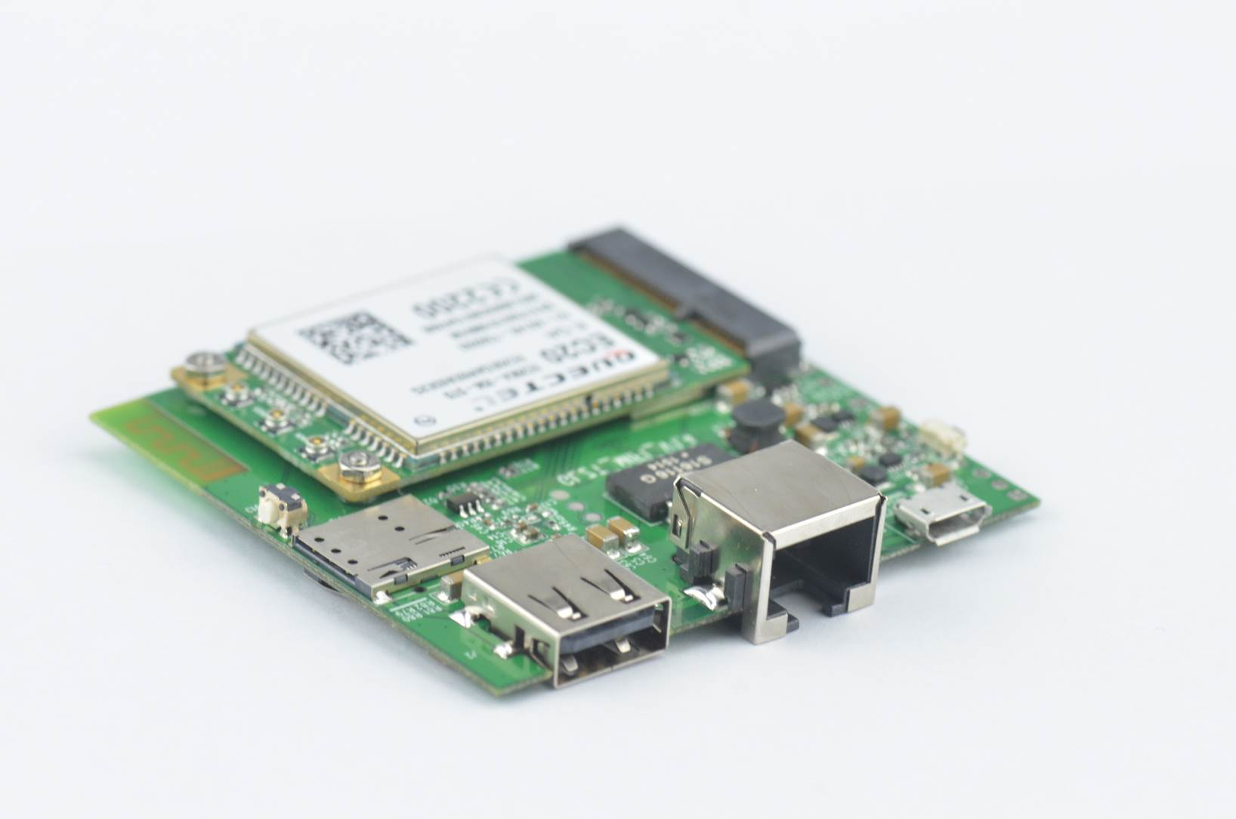
CPU | Atheros AR9331, @400MHz
Memory | DDR 64MB/ FLASH 16MB
Interfaces | 1 WAN, 1 USB2.0, 1 micro USB (power)
Frequency | 2.4GHz
Transmission rate | 150Mbps
Tx power (maximum) | 18dBm
Protocol | 802.11 b/g/n
Power supply | 5V/1A
Power consumption | <2W
Dimension | 60*60*15mm, 130g

Interfaces
MiFi board provides abundant interfaces. The buttons and LEDs may not be well configured in the default firmware.

Power Button (only for battery powered):
- Press to show battery power status
- Long press to turn on/off the board

Reset button:
- Configurable in OpenWrt scripts at /etc/rc.button/reset

SIM slot:
- Nano SIM slot, please use a nano SIM card, not trimmed micro SIM card, which may be a little thick
- Gently insert the SIM card to the slot. It should slip in easily. Don’t push with force, which may damage the slot.

Ethernet Port:
- Early version of the firmware configure it as WAN, only used to get IP from routers
- The newest firmware configure it as LAN by default. Plug a cable to it from your computer will get an IP address.
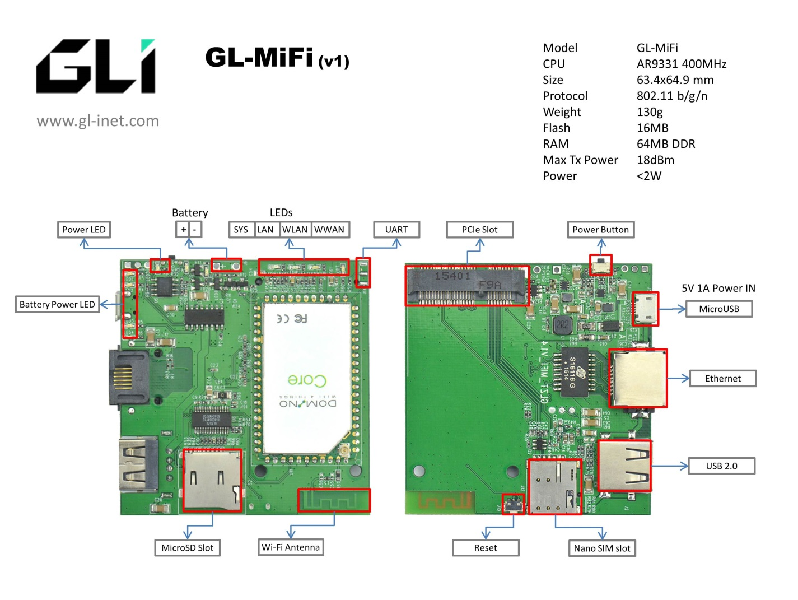

Compatible 3g/4g modules
GL-Mifi is compatible with most PCIe 3G/4G modules. We have three modules tested.
- 3G: Quectel UC20,
- 4G: Quectel EC20, HUAWEI ME909s-821
During the first time you use the mifi board:
- Plug your module in the PCI-E slot of GL-MiFi
- Insert your Nano SIM card to the SIM card slot
- Power the board up using MicroUSB power input, or using 3.7V LiPo batteries.
- Connect to the board using Ethernet cable or using Wi-Fi. The default SSID should be Domino-xxx.
- If possible, solder the UART serial connector and connect via an USB-UART adapter.
- SSH to the board 192.168.1.1 or using serial, check if the modem has been recognized.
ls /dev/ttyUSB*
- If the console displays ttyUSB0, ttyUSB1, ttyUSB2, ttyUSB3 and ttyUSB4 (as figure shown below), that means GL-MiFi identified the module and we can then configure the MiFi.
For Quectel EC20, and UC20, both the data port is /dev/ttyUSB3, the AT command port is /dev/ttyUSB2
For Huawei ME909s-821, the data port is /dev/ttyUSB0

Quick start

Prepare
You need to make sure you have the correct model. For example, if you are using a 4GLTE SIM card, it will not work on UC20 3G module. But a 3G SIM card will work with EC20 4G module.
You need to get some basic information from your telecom service provider, including:
- Service Type: UMTS, EVDO or LTE
- APN: This is generally needed
- Username and password: may not be necessary
- Dial number: may not be necessary

Web Setting
After you connect to the board using Wi-Fi or Ethernet cable, you can using a browser to access http://192.168.1.1. We have a webUI so that you can setting some basic parameters.
Click the “NETWORK” link on the left and you can set the parameters. In the UI, there may be only UMTS and EVDO to select. If you want to setup LTE connection, using SSH or UART.
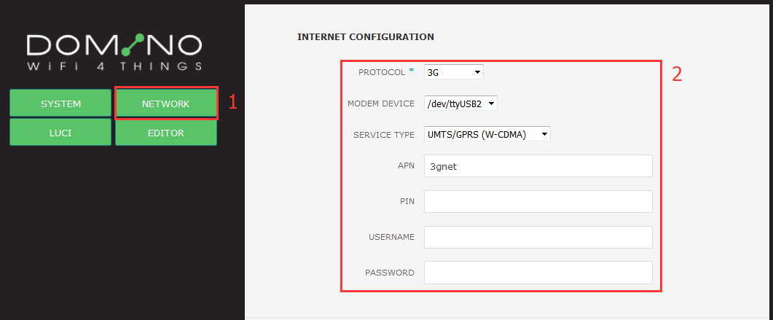

Using winscp via SSH
If you are using Windows, winscp is a good tool to manipulate the settings.
First connect to the board using winscp.
Second, modify file content directly. If you want to modify network configuration, “/etc/config/network” is the correct file to modify.
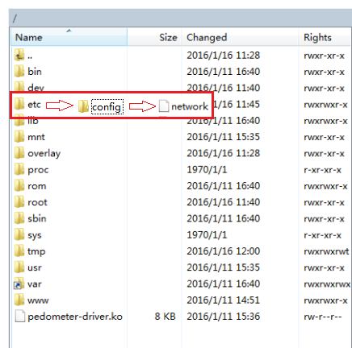

Using vi via SSH/serial
If you are using Linux or OSX, you can use ssh directly or do this using the serial console.
ssh root@192.168.1.1
If you have set up a password, use the password to login. If you didn’t set up a password, don’t use ssh, use telnet instead.
telnet 192.168.1.1
Using “vi” to modify network configurations:
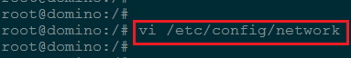
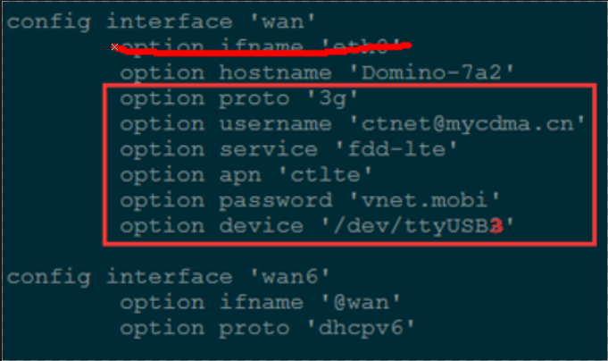
For 4G-LTE, change the service to “fdd-lte”, for 3G umts, change service to “umts”, for evdo, change to “evdo”.
After you change the settings, restart the network:
/etc/init.d/network restart
If you are sure that your settings are correct, after restarting the network or restarting the router, you keep getting “error -2” error messages, please unplug the power then plug the power again, which do the trick.

Change the Ethernet to WAN or LAN
The Ethernet maybe configured as WAN or LAN, change the settings by editing /etc/config/network
Change to WAN
config interface ‘lan’
# option ifname ‘eth0’ #comment or delete this line

config interface ‘wan’
option ifname ‘eth0’
option proto ‘dhcp’

Change to LAN
config interface ‘lan’
option ifname ‘eth0’
option …

config interface ‘wan’
# option ifname ‘eth0’ #comment or delete this line
option proto ‘dhcp’

Check 3G status
If the device connected to the 3G/4G network successfully, you should be able to see “3g-wan” network interface.
root@dominomifi:/# ifconfig 3g-wan
3g-wan Link encap:Point-to-Point Protocol
inet addr:10.72.216.206 P-t-P:10.64.64.64 Mask:255.255.255.255
UP POINTOPOINT RUNNING NOARP MULTICAST MTU:1500 Metric:1
RX packets:2217 errors:0 dropped:0 overruns:0 frame:0
TX packets:1661 errors:0 dropped:0 overruns:0 carrier:0
collisions:0 txqueuelen:3
RX bytes:2600234 (2.4 MiB) TX bytes:152126 (148.5 KiB)

AT command
For UC20/EC20, /dev/ttyUSB2 is for AT commands. First send the commands to the port, then get the output from the port. For example:
echo -e "AT+xxx \r\n" > /dev/ttyUSB2
cat /dev/ttyUSB2

Comgt – a quick tool
There is a build-in tool called “comgt” which you can quckly to check if you SIM card is registered or not. This should give the correct output before you set up the apn and start network connection.
root@dominomifi:/# comgt
Trying list of devices
SIM ready
Waiting for Registration..(120 sec max)
Registered on Home network: "one2free",6
Signal Quality: 14,99

Request International Mobile Equipment Identity
Command: [echo -e "AT+GSN\r\n" > /dev/ttyUSB2]
See the result: [cat /dev/ttyUSB2]
Correct result:
AT+GSN
861075021617089
OK

If you get the similar number, it means that the UC20’s connection is OK.
Wrong result:
AT+GSN
ERROR

Request SIM’S CCID
Command: [echo -e "AT+QCCID\r\n" > /dev/ttyUSB2]
See the result: [cat /dev/ttyUSB2]
Correct result:
AT+QCCID
+QCCID: 89860115851079757018
OK

If you get the similar number, it means that the connection of SIM-card is OK.

Wrong result:
AT+CCIDI
ERROR

Request IMSI
Command: [echo -e "AT+CIMI\r\n" > /dev/ttyUSB2]
See the result: [cat /dev/ttyUSB2]
Correct result:
AT+CIMI
460010529708870
OK
Wrong result:
AT+CIMI
ERROR

Check Network Registration
Command: [echo -e "AT+CREG?\r\n" > /dev/ttyUSB2]
See the result: [cat /dev/ttyUSB2]
Correct result:
AT+CREG?
+CREG: 0,1
OK
If you get the similar result, it means that your SIM-card has registered in telecom operators
Wrong result:
AT+CREG?
ERROR

Signal Quality Report
Command: [echo -e "AT+CSQ \r\n" > /dev/ttyUSB2]
See the result: [cat /dev/ttyUSB2]
Correct result:
+CSQ: 21,99
OK
This first number—“21” is the result. We usually get the value number is 18~23.
Wrong result:
AT+CSQ
ERROR

Query The Currently Selected Network Operator
Command: [echo -e "AT+COPS?\r\n" > /dev/ttyUSB2]
See the result: [cat /dev/ttyUSB2]
Correct result:
AT+COPS?
+COPS: 0,0,"CHN-UNICOM",6
OK
The currently network operator is ChinaUnicom
Wrong result:
AT+COPS?
ERROR

Other AT Instructions
If you want to know more, please refer Quectel_UC20_AT_Commands_Manual_V1.5.pdf

GPS Location
This only applies to Quectel UC20 3g module, which has GPS built in.
Initialization Command:
echo -e "AT+QGPSCFG=\"outport\",\"usbnmea\" \r\n" > /dev/ttyUSB2
echo -e "AT+QGPSCFG=\"nmeasrc\",1 \r\n" > /dev/ttyUSB2
echo -e "AT+QGPSCFG=\"gpsnmeatype\",1 \r\n" > /dev/ttyUSB2
echo -e "AT+QGPSCFG=\"glonassnmeatype\",4 \r\n" > /dev/ttyUSB2
echo -e "AT+QGPSCFG=\"glonassenable\",0 \r\n" > /dev/ttyUSB2
echo -e "AT+QGPSCFG=\"odpcontrol\",0 \r\n" > /dev/ttyUSB2
echo -e "AT+QGPSCFG=\"dpoenable\",0 \r\n" > /dev/ttyUSB2
echo -e "AT+QGPS=1 \r\n" > /dev/ttyUSB2
Location Command:
echo -e "AT+QGPSLOC? \r\n" > /dev/ttyUSB2
cat /dev/ttyUSB2
Module Closure:
echo -e "AT+QGPSEND \r\n" > /dev/ttyUSB2

Install packages and Compile firmware

Install packages
You can install applications to your board from openwrt repo.
opkg update
opkg install [package name]

The current firmware is still an engineering firmware so you may not install kernel modules directly in this way. You can compile your own firmware.

Compile your firmware (Ubuntu)
ATTENTION: A firmware compiled using the following steps seems not works with EC20 4G module correctly. Still checking the problem.
We strongly suggest you get a Linux machine for development with the MiFi board. However, using Linux in virtual machine is fine. The following guide is for Ubuntu.

Install some software
#sudo apt-get update
# sudo apt-get install subversion build-essential git-core libncurses5-dev zlib1g-dev gawk flex quilt libssl-dev xsltproc libxml-parser-perl mercurial bzr ecj cvs unzip

Get openwrt source
git clone https://github.com/domino-team/openwrt-cc.git openwrt-mifi

Update and install feeds
cd openwrt-mifi
./scripts/feeds update -a
./scripts/feeds install -a

Copy files
We need to copy some files to OpenWrt tree, including default configurations (“files”), software packages (“dl”) and Domino WebUI (“domino”).
cp files to openwrt-mifi/ -r
cp dl to openwrt-mifi/ -r
cp domino to openwrt-mifi/package/ -r

Menuconfig and compile firmware
Type “make menuconfig” and choose the packages that you want to compile. Here you need to choose the Target profile as “GL-Domino” and then choose “domino-mifi” package. All the dependent packages will be selected automatically.
make menuconfig
Target profile(Domino Wifi for things) --->
domino --->
<*>domino-pi
make V=s -j5
By adding “-j5” we use multi-thread to compile the firmware. If you have errors, just remove this parameter.
make

Finally, you can get what you want firmware at [openwrt-mifi/bin/ar71xx/],firmware’s name is [openwrt-ar71xx-generic-domino-squashfs-sysupgrade.bin]

Troubleshooting

No ttyUSB0~ttyUSB4
This generally means the driver is not installed or the module is not recognized. You may need to check the connections of the module

Field: [option_instat_callback: error -2] appears after startup
For some complicated reasons:
- Bad contact of SIM Card.
- No antenna inserted.
- Wrong operator parameters.
- No network.
- Data interface (ttyUSBx) configured incorrectly.
When this happens:
- Check connection
- Connect antennas
- Correct network settings
- After you have done the above, try to restart network by execute /etc/init.d/network restart . If the error still exists, try to unplug the power and plug the power again. Simply reboot the device without unplug the device may not help.

